Cree Lesson

This Cree lesson is directed towards the young learners in the elementary years, around the grade 2-7 levels. The learner must have knowledge of Cree words like: nouns, verbs, pronouns, pre-verbs, particle words, VAI sentence formatting, and VTA sentence formatting. The same knowledge can be taught to any age and level of learner, but the lesson would have to be modified. For example, the knowledge I have accumulated has come from a Cree 100 class I am currently in at the University of Regina.

The Lesson Plan:
- Class Scavenger Hunt
- Body Break
- Cree Bingo

The Detailed Lesson Plan:
- Class Scavenger Hunt:
- I have attached photos of the Cree scavenger hunt clues under this link on my E-Portfolio

Subject/Grade: CREE (primary/beginner level)

Lesson Title: Class Scavenger Hunt

Teacher:

Stage 1: Identify Desired Results

Outcome(s)/Indicator(s):
- Encourage teamwork
- Encourages working together
- Allows for social interaction between peers
- Gaining better understanding of Cree VAI and VTA sentence formatting
- Allows for self-assessment on student’s own ability
Key Understandings: (‘I Can’ statements)  - I can read Cree words  - I can format a Cree sentence  - I can work cooperatively with my peers  - I can stay on task  - I can complete each clue in order to move onto the next | Essential Questions:  - How will I encourage my teammates positively when I see them struggling to complete a clue?  - How will I be a respectful teammate when it is not my turn?  - How will I make good usage of my time when trying to complete a successful sentence? – knowing speaking chart, etc.  - What are the best steps in order to successfully finish each Cree sentence properly

Prerequisite Learning:

Students must understand or have a grasp on the concept of the VTA’s and VAI’s Cree Speaking Chart. Students must know some animate and inanimate nouns and other known Cree words taught in lessons leading up to this.

Instructional Strategies:
- Physically (kinesthetic) moving their bodies while engaging in activity
- Verbally (linguistic) speaking each sentence out loud using words
- Aural (auditory) hearing the sound of each clue when read
- Visually (spatial) using the materials to arrange each sentence

Stage 3: Build Learning Plan
Set (Engagement): Length of Time: 5 minutes  (Get their attention then tell them what you are going to learn through this lesson)  - Let the students know that there is a special scavenger hunt set up for them  - In order to join the scavenger hunt, they must have their listening ears turned on and be fully engaged to participate  - Split the students up into even teams and have the students name their team a word in Cree  Development: Time: 25 minutes  - The bags hidden contain Cree words that will form a sentence  - Each bag is labeled a number in Cree (peyak, niso, nisto..)  - Each bag will contain VTA or VAI sentences. The sentences will be scrambled. Each team of students will need rearrange the sentence pieces to format the correct sentence before finding their next bag  - Once the first group has completed their sentence they will sit respectfully and wait until the next team is completed  - Once all teams are done, each team will have a chance to read our their sentences and translations to the class  - After hearing all of the sentences from the groups, each team must brainstorm what the theme of each sentence is.. (this case “getting ready”)  - The students must work together to come up with the common theme between sentences. Once the class has guessed correctly, the class is rewarded (pencil, early recess, etc.)  Closure: Time: 5 minutes  - Ask students what they learnt from this lesson  - Each student must tell the teacher one Cree sentence they remember before finishing the day | Instructional Strategies:  - Verbally announce what the plan in  - Physically show them what each bag will look like that they’re searching for  Materials/Resources:  - Bags (with clues)  - Prize (pencils, candy, etc)  Possible Adaptations/  Differentiation:  - Lower level Cree students have the option to distinguish single words rather than distinguishing full sentences at a time

- Body Break:

The activity:
Our Walk in the Forest Brain Break activity is a great allow young students burn extra energy and become more focused for the next activity. The teacher will ask the students to stand and clear their personal space. The teacher will tell a story in Cree (using vocabulary that is known by the class) while the students use movements to imitate what is happening in the story. For example, the teacher says, Niwî-kwâskohtinân asici wâpos kêsiskaw (we are going to jump with rabbits quickly), the class will demonstrate the sentence by hopping on the spot. If this activity is done frequently with a class, the students would be able to learn the stories and repeat it back to the teacher while doing the actions. This activity would benefit in learning Cree numbers by introducing counting steps within the story. For example, the teacher could suggest jumping three times while the students respond by counting to three in Cree. This activity has plenty of wiggle room to adjust the story for the different levels of Cree fluency. The key concept of this activity is to get students moving while rehearsing Cree vocabulary as a different way of learning the words.

Duration: 10-15 minutes

Rules and safety hazards:
This activity has no rules except you must stay stay in your own personal area, we are doing each activity on the spot to avoid any collisions. This activity involves no materials or equipment, and we want everyone to be aware of their surroundings. Be careful around the desks, push in all chairs and move all bags under the desks. Keep all legs and arms in your own personal area and cautious of what and who is around you.

Age group:
This activity is recommended for ages pre-k to grade 5 but it can be done with middle school years. Who this activity would be appropriate for more so depends on the Cree fluency of the students, but modifications can be made to appropriate for all levels. Our story in particular would be appropriate for beginner Cree speakers with familiarity with VAI sentence formation, VTA sentence formation, nouns, and temporal Cree words.

Our Story:
(Cree Translation, English Translation)

Niwî-pimohtânân nohcimihk anohc
We are going to walk in the forest today

Niwî-mâci-postayiwinisoânân. Niwî-nitawi-postiskawânân astotin, maskisina, êkwa mîna mitâswak
We are going to begin to dress. We are going to go and put on a hat, shoes, and also pants.

Niwî-kwâskohtinân asici wâpos kêsiskaw
We are gong to jump with rabbits quickly

Niwî-nitawi-pakâsimonân asici kinosêw atâmipihk
We are going to go and swim with fish underwater

Niwî-kakwê-ocîmânân ayîkis kîmôc
We are going to try to kiss a frog secretly

Pâtimâ, niwî-môwânân maskosiy asici môswa
Later on, we are going to eat grass with a moose

Niwî-mêtawânân êkwa niwî-kâsôpayihanân asici minôs
We are going to play and we are going to hide quickly with a cat

Niwî-wâpamânân sîsîp tahkohc sîpiy
We are going to see ducks on top of the river

Niwî-têpwêwnân asici maskwa
We are going to yell with bears

Mâskôc, niwî-pimâhtawîwnân mohcihk asici kinêpikwak
Perhaps, we are going to crawl down on the floor with snakes

Niwî-ispâhkêkocinnân asici piyêsis tahkohc mistikwas
We are going to fly with birds on top of trees

Piyisk, niwî-ati-kîwânân mêkwâc
Finally, we are going to begin to go home right now

- Cree Bingo:
- Animate nouns used to make our BINGO cards:
  - Moose – Môswa
  - Bird – piyêsîs
  - Duck – sîsîp
  - Snake – kinâpik
  - Bear – maskwa
- Inanimate nouns used to make our BINGO cards:
  - Flower – wâpikwaniy
  - River – sîpiy
  - Egg – wâwi
  - House – wâskahikan
  - Hat - astotin

BINGO - ANIMATE
 | 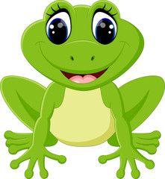
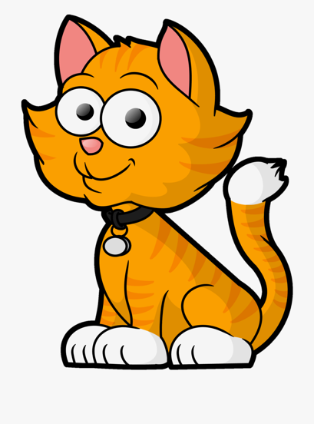 | 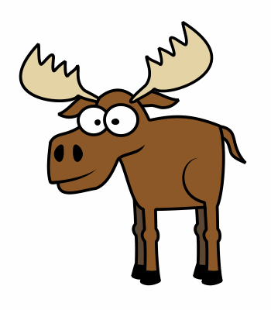 | 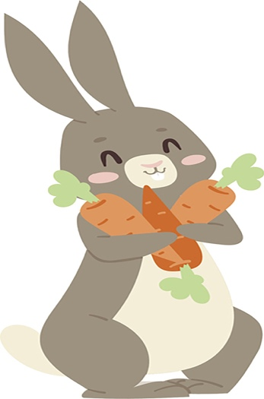
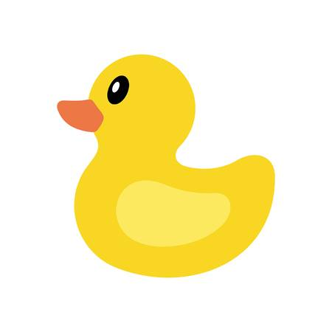 | 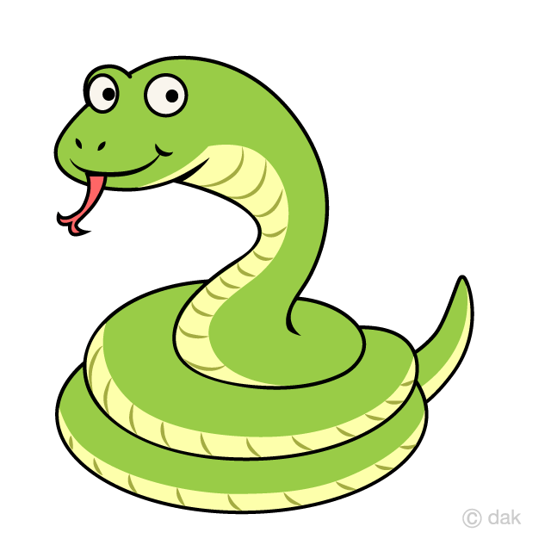 | 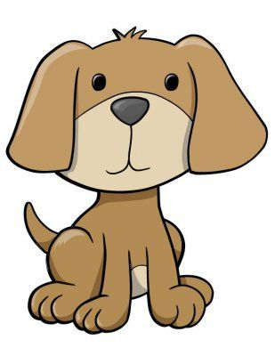

BINGO – INANIMATE
 | 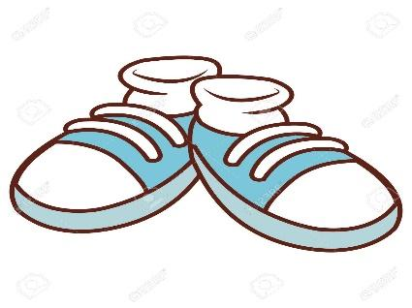
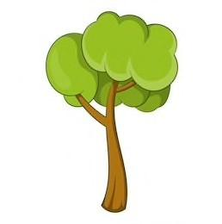 | 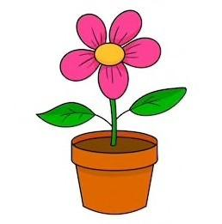 | 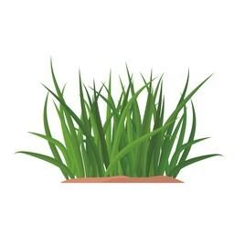
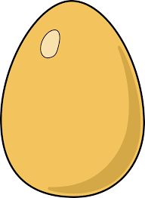 | 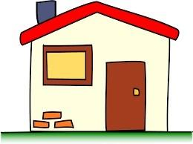 | 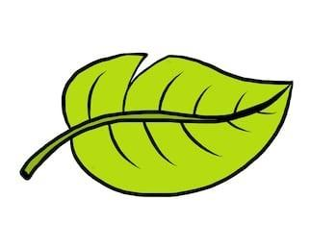

Subject/Grade: CREE (primary/beginner level)

Lesson Title: Cree BINGO

Teacher:

Stage 1: Identify Desired Results

Outcome(s)/Indicator(s):
- Encourages individual work
- Encourages learning in a fun way
- Allows students to self-assess their knowledge of Cree nouns
- Determining inanimate and animate nouns
Key Understandings: (‘I Can’ statements)  - I can read and distinguish inanimate nouns  - I can read and distinguish animate nouns  - I can work independently  - I can have fun while learning | Essential Questions:  - What inanimate nouns do I have on my Bingo sheet and am I able to check the correct ones off?  - Which animate nouns do I have on my Bingo sheet and am I able to check the correct ones off?  - How will I be a respectful player during out Bingo activity? – Listening ears, etc.

Prerequisite Learning:

Students will be able to recognize each animate and inanimate noun orally and visually

Instructional Strategies:
- Physically (kinesthetic) placing a check on each word announced on their BINGO sheet
- Aural (auditory) hearing each word announced
- Visually (spatial) seeing each word announced

Stage 3: Build Learning Plan
Set (Engagement): Length of Time: 2 minutes  (Get their attention then tell them what you are going to learn through this lesson)  - Invite the classroom to engage in a fun game  - In order to play, each student must use their listening ears and be respectful listeners (no talking)  Development: Time: 10 minutes  - A BINGO card (5x5) or (3x3) will be used  - This BINGO card is made by the teacher as there isn’t a ‘free space’  - The pictures are known objects/animals  - Each picture has a corresponding Cree word that have been gone over in class several times  - Animate animals sheet is handed out first  - Teacher will call out the nouns in Cree and the students will be able to ‘dab’ off each one as they get it  - Once a student has a line (vertical, horizontal or diagonal) they will say “BINGO”  - Teacher will check the card and make sure they are correct  - They’re then the BINGO winner  - Repeat steps with inanimate nouns…  Closure: Time: 3 minutes  - Ask students what they learnt from this lesson  - Each student must tell the teacher one inanimate and animate Cree noun they remember before finishing the day |  | Instructional Strategies:  - Verbally explain the activity  - Physically show class how to correctly check off their BINGO sheet  Materials/Resources:  - BINGO sheets  - Dabber/marker/etc

